****DanielCHAPTER 9 Part 2**

**Basic Study of the Book of Daniel *compiled by Gaetan, read by Anna***

**The fulfillment of the first part of this amazing prophecy inspires faith that the rest of it will be fulfilled just as accurately. For, as you may have noticed, there is one *“week”* of years unaccounted for. Verse 24 refers to *“seventy weeks”* in order to *“make an end of sins”* and *“bring in everlasting righteousness.”***

**However, verses 25 and 26, which predict the year of Christ’s death, only account for 69 *“weeks.”* What and when is this last week? It certainly wasn’t fulfilled seven years after Jesus was crucified and then rose from the dead, since an era of *“everlasting righteous­ness”* was not ushered in; nor was the vision and prophecy *“sealed up”* or completed.**

**Professor John Lennox expands on that final week:**

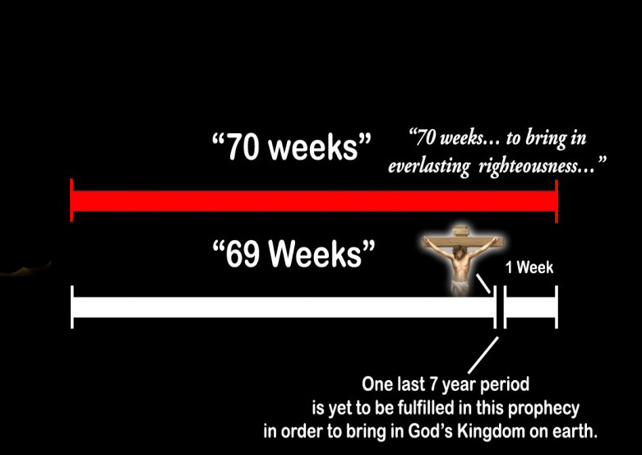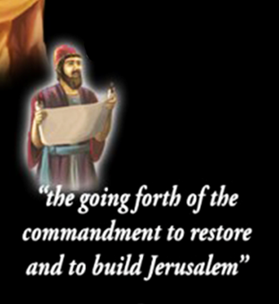 **“There are two main interpretations of the final week of Daniel’s prophecy regarding the seventy weeks. The first, often called *“the traditional view”,* is that the seventieth week immediately follows the first sixty-nine. The second holds that the seventieth week is still in the future, so that there is an unspecified gap between it and the first sixty-nine weeks. The obvious merit of the first view is that it treats the seventy weeks as a continuous period of time, without the introduction of an *“unnatural”* gap. However, when we try to make sense of it in historical terms, we run at once into serious difficulties.**

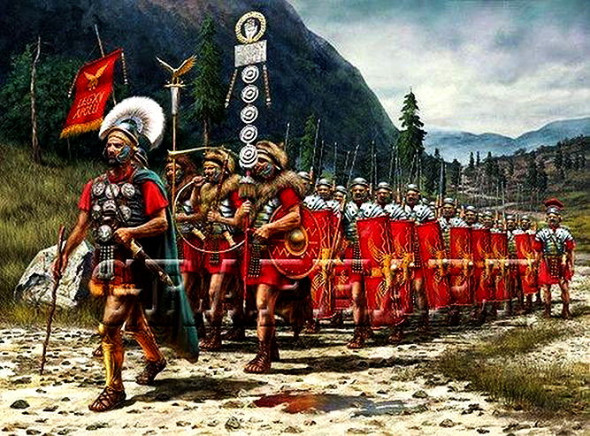**Using the example of Daniel 9:24 --** *“Seventy weeks are determined for your people and for your holy city, to* ***finish the transgression****, to make* ***an end of sins****, to make* ***reconciliation*** *for iniquity, to bring in* ***everlasting righteousness****, to seal up the vision and prophecy, and to anoint the Most Holy”* **-- John Lennox goes on to say:**

**“Certainly, we can say that Christ’s death atoned for iniquity; but it is very hard to see how other things mentioned were fulfilled in the seven-year period following his death. Indeed, far from solving Israel’s and Jerusalem’s problems, the situation there rapidly got worse, leading up to the destruction of the temple by the armies of Titus in AD 70, and the dispersion that followed lasted for centuries.**

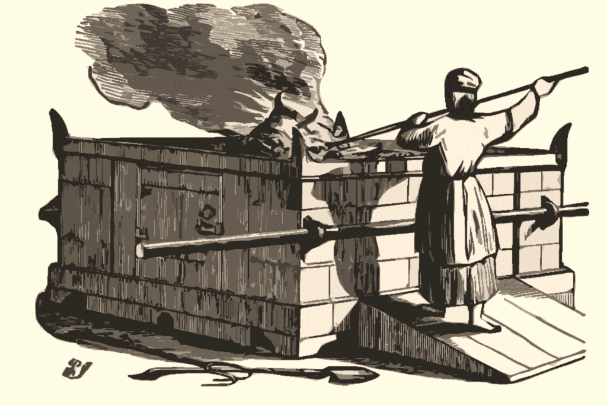**“Moreover, if the seventieth week follows at once on the first sixty-nine, we must ask what Daniel is referring to when he writes:**

***“…****and to* ***the end there shall be war. Desolations are decreed****. And* ***he shall make a strong covenant*** *with many* ***for one week****, and for half of the week he shall put* ***an end to sacrifice and offering****. And on the wing of abominations shall come one who makes desolate, until the decreed end is poured out on the desolator****.” (Daniel 9: 26– 27)***

**“There seems to be nothing in the history of the time that could fit this description. For instance, sacrifice and offering continued in Jerusalem for years after the death of Christ, until the destruction of the city in AD 70 – much longer than seven years after the crucifixion. The difficulties rapidly become insuperable.**

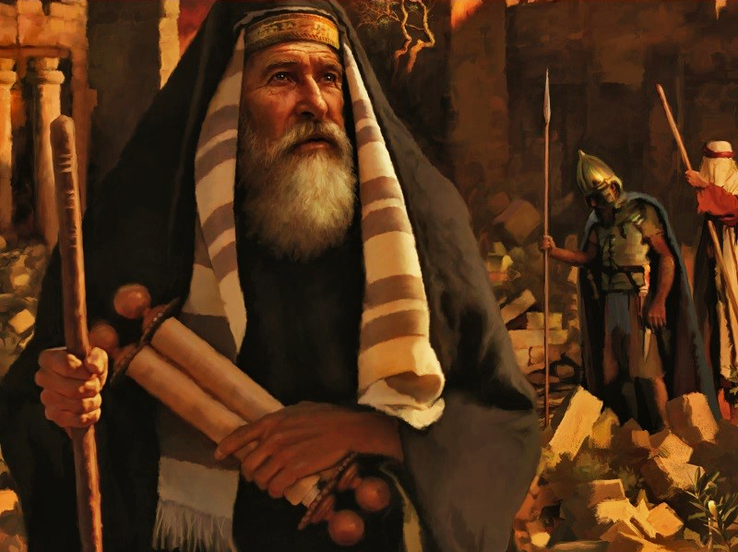**“Some scholars date the seventy weeks from the earlier decree that Artaxerxes gave to Ezra (457 BC), even though it refers to the reconstruction of the temple and not the city. They calculate that the sixty-nine weeks run up to the time of the Lord’s anointing at his baptism. They take the seventieth week as following immediately, with Christ dying in the middle of the week (around three-and-a-half years after his baptism) – and so, of course, after the sixty-nine weeks. The end of the seventieth week is then dated to the martyrdom of Stephen and the call of the apostle Paul. The covenant in *Daniel 9:27* is held to be the New Testament that Christ made with his disciples at the Last Supper.**

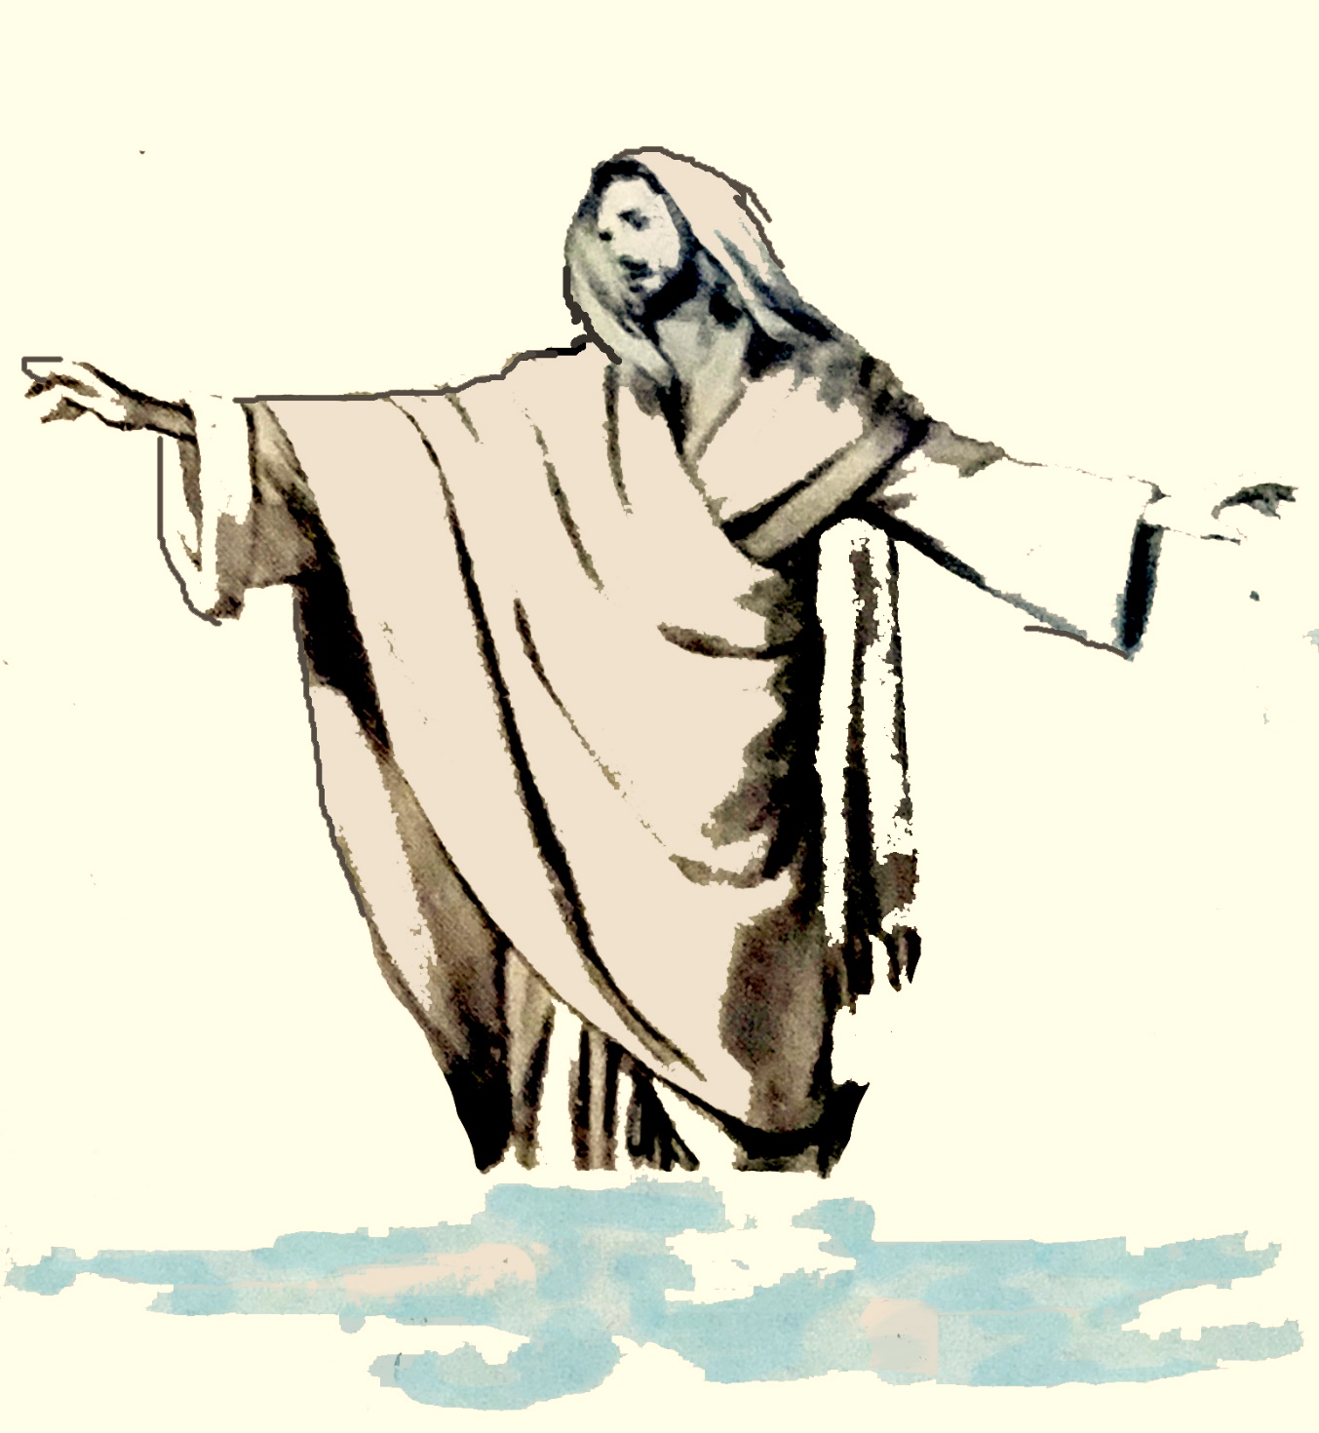

**“This view certainly takes seriously the predictive value of the first sixty-nine weeks. However, its interpretation of the seventieth week seems (to me, at least) to be very strained. For instance, the week would have been completed long before the destruction of the city, whereas the covenant that Christ made was not limited to seven years. As the vision of *Daniel 7:13-14* reveals, justice is not done, the saints do not receive the kingdom, nor is everlasting righteousness brought in, until *the Son of Man comes on the clouds of Heaven.* (Mat.24:30) This fits in with what the apostle Paul told the philosophers at Athens – the Lord Jesus would return to *judge the world in righteousness.* (Acts 17:31)**

**DAN.9:27** And he shall **confirm the covenant** with many for **one week**: and in the **midst** **of the week** he shall cause the **sacrifice and the oblation to cease**, and for the overspreading of **abominations** he shall make it **desolate**, even until the consummation, and that determined shall be poured upon the desolate.

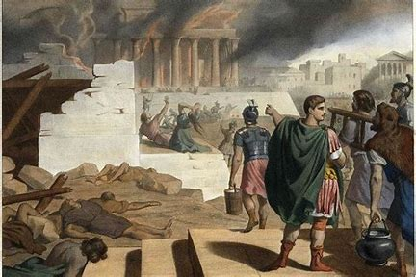**“The question then arises: what does the rest of the above passage refer to? The mention of abominations and desolations reminds us of *Daniel 8:12-13*, and also *11: 31*, as we shall see later. These two passages both have a double reference – to Antiochus Epiphanes and to the time of the end. Could it be that *Daniel 9* is doing a similar thing – but this time looking at the time of the end through the lens of AD 70? That is,** **the prince who is to come is Titus, who shall destroy Jerusalem, and there will follow an indefinite period of war to the end.**

**Then the *“he”* who is referred to next in the phrase *“he shall confirm [a] covenant with many for one week”* is not Titus but someone who, like Titus, desecrates the sanctuary in Jerusalem; the final embodiment of Gentile power: the man of lawlessness referred to in *2 Thessalonians*.**

**Titus and the destruction of Jerusalem in 70 AD**

**“It is arguable that there is internal evidence in *Daniel 9* that the final week does not run immediately after the first sixty-nine. There is an implied gap.” (End of comments from J. Lennox)**

**If so, then that prince that shall come is also referring to the Antichrist and he is the one that shall confirm the Covenant with many for seven years. He promises seven years of religious freedom for all, and so the Jews will be able to rebuild their Temple and all this sort of thing.** **It's the very prince we have been studying about, talking about and studying the prophecies about in *Daniel 7 and 8.***



**This *“one week”* does not follow the other 69 chronologically. This is the week that is yet in the future, and this man (who was described in *Daniel 7 and 8*) is referred to in *Revelation 13* as the *“beast.”*  Many scholars believe that Israel incredibly will accept him as their messiah, but in the middle of the *“week”* he will break his covenant, stop the services of the rebuilt temple, and place an image in it. *(Revelation 13)* Israel and the world will suddenly realize this is not the millennium after all – in fact it will be the great tribulation.  Only the return of Christ will stop this time of terror. *(2Th.2:3-4)***

***\*\*REV.13:14, 15 …****saying to them that dwell on the earth, that they* ***should make an image to the beast****, which had the wound by a sword, and did live.**And he had power to* ***give life unto the image*** *of the beast and that the* ***image of the beast*** *should both speak, and cause that as many as would not worship the image of the beast should be killed.*

***\*\*MAT.24:15*** *When ye therefore shall see* ***the abomination of desolation****,* ***spoken of by Daniel the prophet****, stand in the holy place, (whoso readeth, let him understand)*

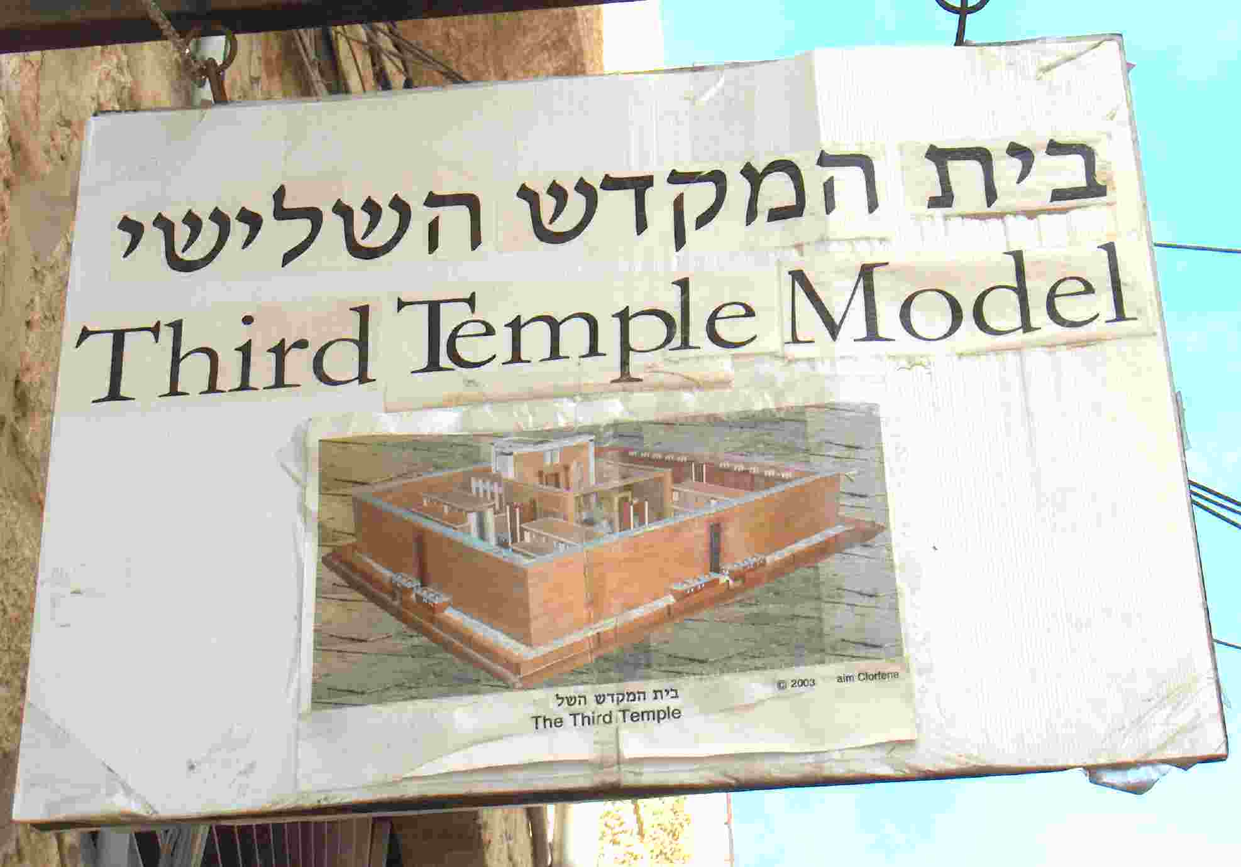

**This covenant, which plays a pivotal role in End time events, apparently allows the resumption of Jewish temple worship with all its requisite animal sacrifices. We deduce that because, when this covenant is broken in the middle of the seven years, the sacrifice and offering is brought to an end. At the writing of this class, there is no temple and hence no temple worship. But, according to this and other prophetic passages in the Bible, one is going to be built.**

****And at the breaking of this covenant, we are told cryptically that on the wing of abominations shall be one who makes desolate. In *Daniel chapter 11* we are told about the Abomination of Desolation, which is some sort of idol, being placed in the temple. We still don’t know the details. And the peoples of the world are ordered to worship this thing. It is not going to be your everyday idol, either. And all this is going to happen until the consummation, the very end, when God’s frightening judgments are poured out on the desolate, *“The Plagues of the Wrath of God” and “Armageddon.”***

***\*\*REV.16:1*** *And I heard a great voice out of the temple saying to the seven angels, Go your ways, and pour out the vials of* ***the wrath of God*** *upon the earth.*

**Take a moment to study the chart in the following slide:**

**When the battle of Armageddon is over and the Lord has returned, the following stipulations in *Daniel 9:24* will all surely be fulfilled:**

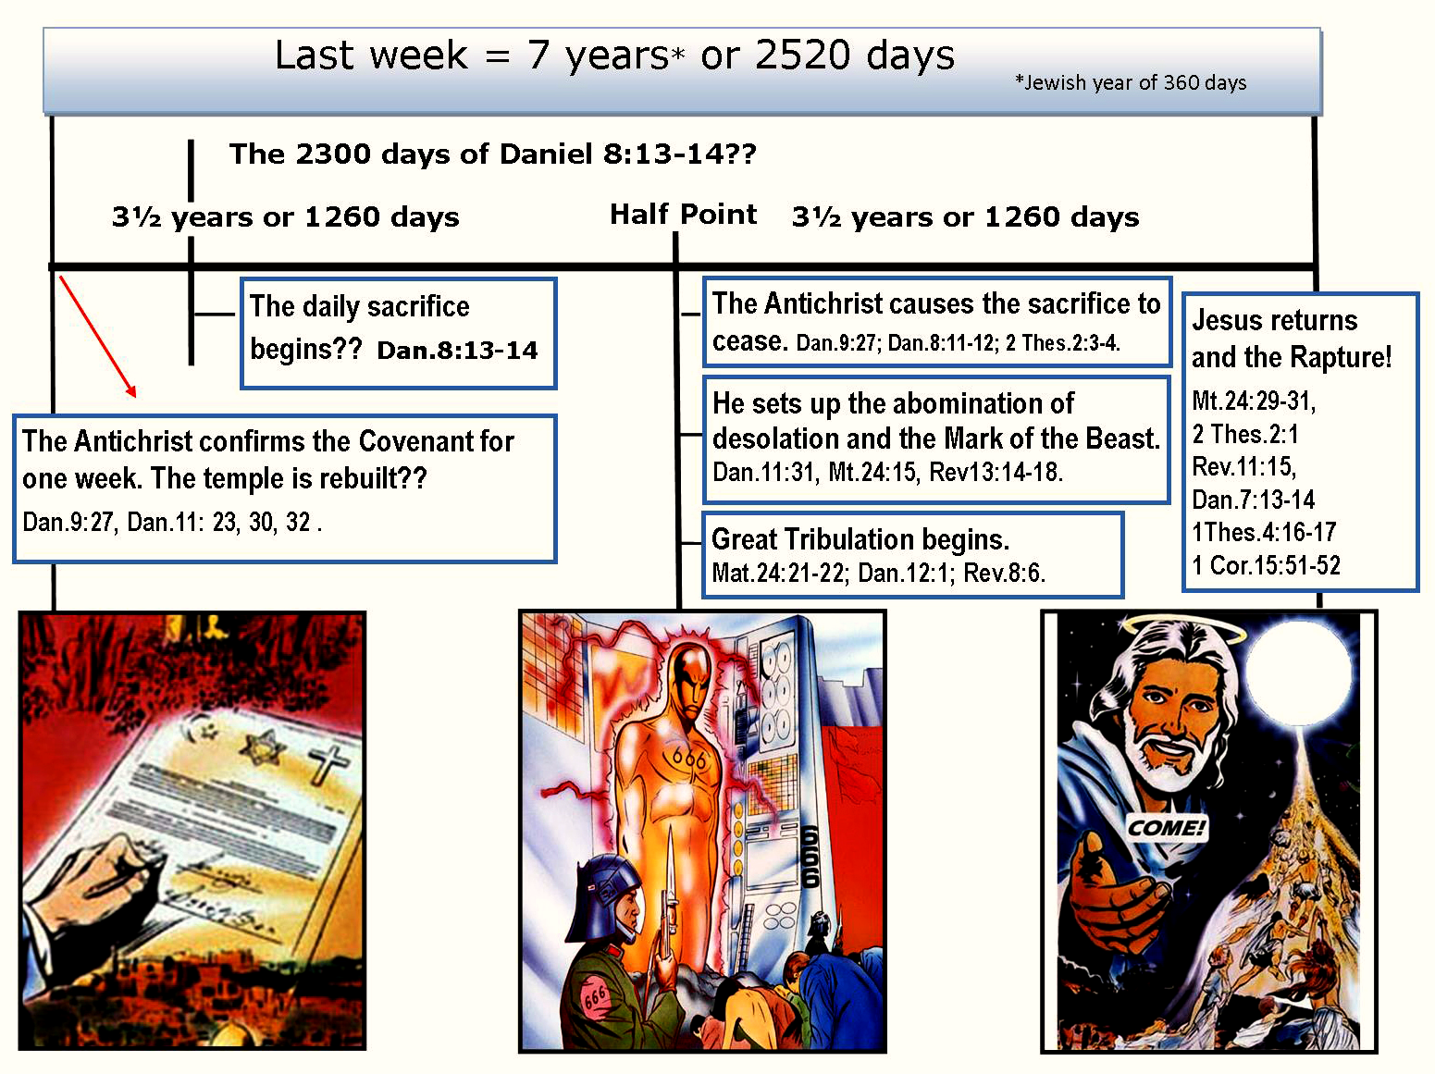

**“*Seventy weeks*** *are determined for your people and for your holy city,* ***to finish the transgression****, to make* ***an end of sins****, to* ***make reconciliation for iniq­uity****, to bring in* ***everlasting righteousness****, to* ***seal up the vision and prophecy****, and to* ***anoint the Most Holy.”***

**Jesus came at the end of the 69th week and died for our sins, and we have thus been 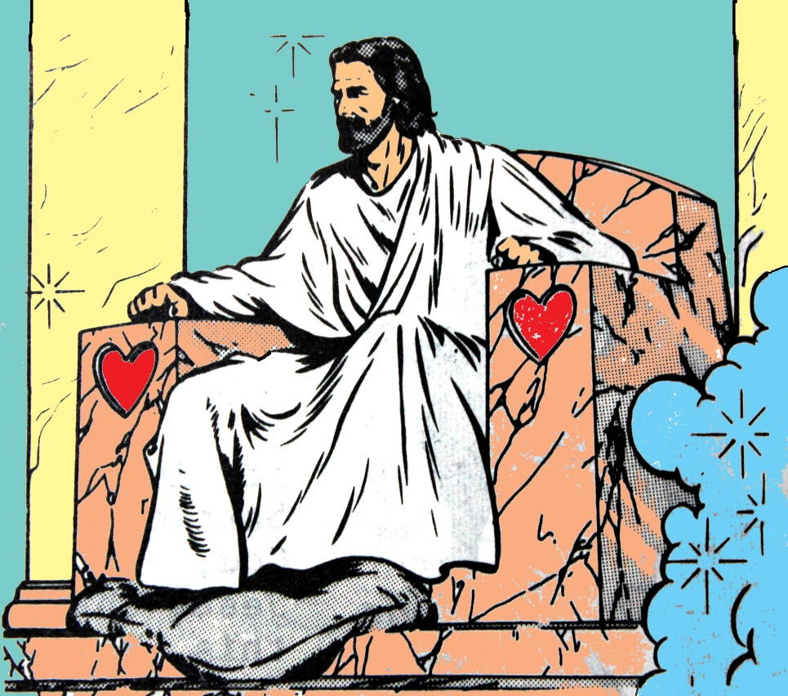recon­ciled. And when the 70th week is completed, the transgression in the temple and the Antichrist’s reign in Jerusalem will be ended. Everlasting righteousness will be ushered in with the establishment of God’s kingdom on Earth after Jesus’ Second Coming, which takes place at the end of the seventh year of the Antichrist’s rule. The vision and prophecy will be fulfilled and sealed, and Jesus will be anointed King of all the Earth.**

***\*\*DAN.2:44*** *And in the days of these kings* ***shall the God of heaven set up a kingdom, which shall never be destroyed****: and the kingdom shall not be left to other people, but it shall break in pieces and consume all these kingdoms,* ***and it shall stand for ever****.*

**Compiled and edited by Gaetan from multiple sources. gaetan.goye@gmail.com**